**Intellectual Property Rights**

Table of Contents

Intellectual Property Laws 1

Differences with Traditional Property 2

Branches of Intellectual Property 3

Intellectual property can be divided into two basic categories: 3

Patents 3

Trademarks 4

Trade Secrets 4

Copyright 5

Infringement 5

Patent Infringement 5

Trademark Infringement 6

Copyright Infringement 6

Intellectual property (IP) is a category of property that includes intangible creations of the human intellect. It basically refers to knowledge. Literary work, paintings, music, software, circuit designs, anything that has been created or thought of but does not have physical existence, all fall into the category of intellectual property.

## Intellectual Property Laws

Intellectual property laws exist to safeguard the creators of intellectual property, so that their creations are used fairly. For example, if we were to invent a piece of software, we could file a patent for that software. The existence of the patent would mean that we would be the only people allowed to produce that software and thus gain all financial benefits from it.

The main purpose of such laws is to encourage the creation of a wide variety of intellectual goods instead of just copying existing creations. The economic incentive of being the only group to profit from the piece of intellectual property also pushes people to create things that would be used widely and benefit everyone.

Generally, however, the rights to intellectual property apply for a limited period of time. After that period, anyone is allowed to use the intellectual property and replicate it. This is why we can paint a copy of the Mona Lisa and post it on Instagram without getting sued by the descendants of Leonardo Da Vinci.

Intellectual property laws can be a little lax, depending on where a person is. For example, many drugs are patented around the world, but developing countries produce the drugs locally anyways. Such violations of intellectual property laws are generally overlooked by the owners specifically because it is happening in a developing country. A developed country would have to pay the original owners if they wanted to produce the drugs locally.

## Differences with Traditional Property

Traditional property like land or goods is tangible. This makes it far easier to protect from unauthorized usage. We can simply put a fence around a piece of land we own if we do not want anyone else to go there. If someone forces there way in, we can have them arrested for trespassing.

Intellectual property on the other hand, cannot be protected in this way. It is indivisible, meaning it is not depleted if others consume it. Oftentimes, especially with piracy, the original author may never even find out that his intellectual property rights were violated. In this way, they may not receive their due royalties or credit. This sort of harm to the owner’s career is also not a problem with traditional property, since traditional property tends to not be created by the owner of the property and thus cannot harm their careers even if it is straight up stolen.

These differences make it difficult to find the right balance when creating intellectual property laws. The laws need to be strong enough to discourage unauthorized redistribution of intellectual property, but also lax enough so as to not prevent widespread use of the property.

## Branches of Intellectual Property

### Intellectual property can be divided into two basic categories:

* Industrial Property – These include patents, industrial designs, trademarks, tradenames and integrated circuit designs.
* Copyrights

### Patents

A patent is a right granted by a government to an inventor or their successor which gives them the right to exclude others from making, using, selling, offering to sell or importing the invention. The patent is granted for a limited period of time under the condition that once the stipulated time period ends, the details of the invention will be disclosed to the public.

We cannot file a patent for any invention or solution to a specific technological problem. The product or process we want to patent must fulfil three criteria:

* It must be new
* It cannot be obvious
* It needs to have industrial applicability

### Trademarks

A trademark is a sign, design or expression that is recognizable and which distinguishes the products or services of a particular trader from similar products or services of other traders. Creating products that use the trademarks of other companies, even if the trademarks are not an exact copy, is a violation of trademark laws.

### Trade Secrets

A trade secret is a formula, practice, process, design, instrument, pattern or compilation of information that is used by a business but is not generally known or reasonably ascertainable. Trade secrets give the owners an advantage over their competitors.

Trade secrets are not directly protected under law. Owners must maintain trade secrets themselves. This has led to business espionage, where trade secrets are stolen from one company and sold to another. Even though trade secrets are not protected under law, it is still intellectual property. As such, if the owners are able to prove that their trade secrets were stolen by an entity, the entity will be liable to pay damages to the owners.

### Copyright

A copyright gives the creator of an original work exclusive rights to it, usually for a limited period of time. In Bangladesh, this time period is 60 years. Copyrights apply to a wide variety of creative, intellectual and artistic work, such as literary work, music, art, software etc. Anyone reproducing the work without proper permission from the owners are in violation of copyright laws.

Copyrights do not protect ideas and information itself, but rather the from in which they are expressed.

## Infringement

Infringement is a violation of intellectual property rights with respect to patents, copyrights or trademarks. Violation of intellectual property rights with respect to trade secrets is called misappropriation.

Infringement may be a breach of civil or criminal law, depending on the type of intellectual property involved and the jurisdiction and nature of the infringement.

### Patent Infringement

Patent infringement usually takes place when someone uses or sells a patented invention without permission from the patent holder. The scope of the patent and the extent of protection is defined in the patent. Generally, patent laws do not apply when the patented invention is being used for research purposes.

There is some debate about how useful or harmful patents are. Some argue that every invention should be free to use publicly, since inventions should lead to the betterment of society. Others argue that inventors should be allowed to profit off of their inventions, at least for some period of time, so that the monetary incentive serves as an encouragement to keep inventing and also as a reward for their work.

### Trademark Infringement

Trademark infringement is when one party uses a trademark that is identical or confusingly similar to a trademark owned by someone else. In many countries, trademarks are protected, even if they are not officially registered. However, registering the trademark provides additional advantages with enforcement of infringement laws.

### Copyright Infringement

Copyright infringement is when a copyrighted product is reproduced, distributed, displayed or performed without consent of the copyright holder. Copyright infringement also applies to derivative work. Essentially, it is piracy.

## Creative Commons Licensing

Creative Commons Licenses are one of several public copyright licenses. Creative commons licenses are used when the original creator of intellectual property wishes to give others different degrees of rights to copy, share and otherwise use their work.

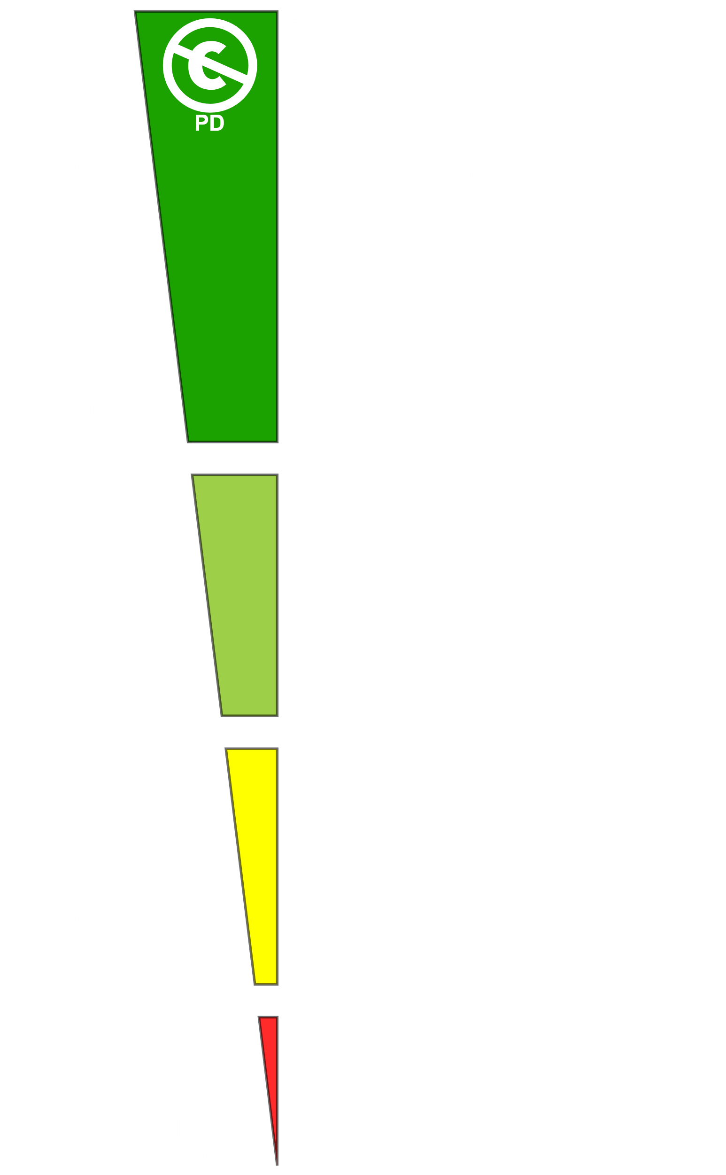

The image above describes the different categories of creative commons licenses available in the world along with the rights and rules associated with each of them. There are essentially four rules:

*  CC BY – This means that the original creator must be given credit regardless of what is being done with the work, even if it being remixed.
*  CC Non-Commercial – This means that the work and any derivatives of it cannot be used commercially.
*  CC Share Alike – This means that the work can only be shared and remixed under the same license.
*  CC No Derivation – This means derivative work based on the original work is not allowed.

Every CC license we will look at now is some combination of (or lack of) these rules.

|  |  |  |  |  |  |
| --- | --- | --- | --- | --- | --- |
| License Name | Sharing | Derivations | Commercial Use | Attribution | Share Alike |
| CC 0 | ☑ | ☑ | ☑ | ☒ | ☒ |
| CC BY | ☑ | ☑ | ☑ | ☑ | ☒ |
| CC BY SA | ☑ | ☑ | ☑ | ☑ | ☑ |
| CC BY NC | ☑ | ☑ | ☒ | ☑ | ☒ |
| CC BY NC SA | ☑ | ☑ | ☒ | ☑ | ☑ |
| CC BY ND | ☑ | ☒ | ☑ | ☑ | ☒ |
| CC BY NC ND | ☑ | ☒ | ☒ | ☑ | ☒ |
| All Rights Reserved | ☒ | ☒ | ☒ | ☒ | ☒ |